GMU Engineering
Concept of Operations

Students(s): Akhil Patel, Godwin Ansu-Gyan

Project Name: Fingertip Screening Device

Introduction

The Purpose of the System
The purpose of the Fingertip Screening Device is to provide a simple, fast way to take a distal phalanx (fingertip) temperature reading and detect when a person’s hand is near the device. The system gives a clear digital display of the temperature in celsius or fahrenheit and uses Green or Red LED’s to alert the operator if the fingertip is properly placed on the thermistor (temperature sensor) in order to ensure that the temperature is being correctly read.

Stakeholders

Patients, nurses, receptionists, teachers, doctors, screening staff, and businesses

Problem addressed
Many environments need quick, simple temperature screening without requiring a full clinical thermometer. This device provides a rapid readout and an alert so the operator can decide whether additional evaluation is needed. The goal is speed, simplicity, and clarity, not medical certification.

System Overview
This device is meant to sit on a desk or check-in station. When a person approaches, the ultrasonic sensor detects the hand. The user then touches the thermistor so the device can read fingertip temperature. The result is shown on a 4-digit LED display, and an audible buzzer signals normal or high temperature.

Key capabilities
- Detect approaching hand using an ultrasonic proximity sensor
- Measure fingertip temperature with a thermistor
- Convert analog thermistor signal through an ADC for processing
- Display temperature clearly on a 4-digit digital display
- LED’s display Hand Proximity: Hand far → red LED, Hand close → green LED
- Send real-time readings to a computer via Thonny for data logging and demonstration
The operator simply powers the unit, guides the user to place their finger correctly, and watches the display/buzzer feedback. No technical knowledge is needed.

Step-by-Step Overview:

Step 1: (Power On & System Start)
When the device is powered on, the Raspberry Pi loads the program written in Thonny.
The program prepares all the components:
INPUTS
- Thermistor input
- Ultrasonic sensor input
OUTPUTS
- Display output
- Red and green LED outputs

Step 2: (Ultrasonic Sensor Watches for a Hand)
The ultrasonic sensor continuously measures the distance in front of the device.
- If no hand is close, the Raspberry Pi turns ON the red LED.
- If a hand is detected within the set distance, the Raspberry Pi turns ON the green LED.
This lets the user know whether they are in the correct position to take a reading.

Step 3: (When the Hand Is Close Enough)
Once the ultrasonic sensor detects the hand:
- The red LED turns off
- The green LED turns on
- The system moves to the temperature measurement step
This ensures the user is placing their hand close enough for a proper reading.

Step 4: (Thermistor Measures Fingertip Temperature)
The thermistor sits where the user’s fingertip touches.
- When the fingertip touches it, the thermistor senses body warmth
- The Raspberry Pi reads the thermistor value (using an ADC if required)
- The software converts this value into a temperature in °C
This temperature measurement step only occurs when the hand is detected by the ultrasonic sensor.

Step 5 (Temperature is Calculated and Sent to Display)
The temperature reading is sent to the digital display.
The display will show the temperature reading similar to: 32°C or 34°F
This is the main output of the device: a simple, easy-to-read temperature value.

Step 6 ( LEDs Continue Showing Hand Presence)
While the thermistor measures and the display updates:
- The green LED stays ON as long as the hand remains within range
- If the hand moves away, the system switches back to red LED ON and stops measuring
The device is now ready for the next user.

Step 7 (System Returns to Monitoring)
After showing the temperature:
- The display holds the result briefly
- The system resets
- The ultrasonic sensor resumes watching for the next hand
(This cycle repeats automatically.)

Operational Overview
- Power on → system initializes
- Ultrasonic checks distance Hand far → red LED, Hand close → green LED
- Finger touches thermistor → temperature measured
- Temperature shown on display
- System resets and repeats
Vision Statement
The Fingertip Screening Device is intended for environments where quick, simple temperature checks are needed, such as clinics, schools, offices, and business entry points. This system supports staff members such as receptionists, nurses, teachers, and screening personnel who need a fast and reliable way to screen individuals without requiring a full thermometer or specialized training. The goal of the device is to provide a clear, instant fingertip temperature reading while guiding the user to place their finger correctly for an accurate measurement. By combining presence detection, visual indicators and a digital display, the system offers an efficient screening method that helps operators decide whether further evaluation is needed. The vision is to create a screening tool that is easy to use, intuitive for all ages, and effective in busy settings.
Mission Requirements
MR.1. The system shall detect when a user’s hand is within the correct screening distance using a proximity sensor.
MR.2. The system shall guide the user into proper finger placement by turning on a red or green LED based on hand distance.
MR.3. The system shall measure fingertip temperature using a thermistor once the hand is in the correct position.
MR.4. The system shall convert the sensor reading into an accurate temperature value displayed in Celsius or Fahrenheit.
MR.5. The system shall present the temperature clearly on a digital display so that the operator can quickly interpret the result.
MR.6. The system shall provide basic auditory or visual feedback indicating either the reading is complete.
MR.7. The system shall reset automatically after each reading so it is ready for the next user without manual intervention.
Operational Scenarios and Use Cases

Scenario 1: Normal temperature reading (everything works, temperature is normal)

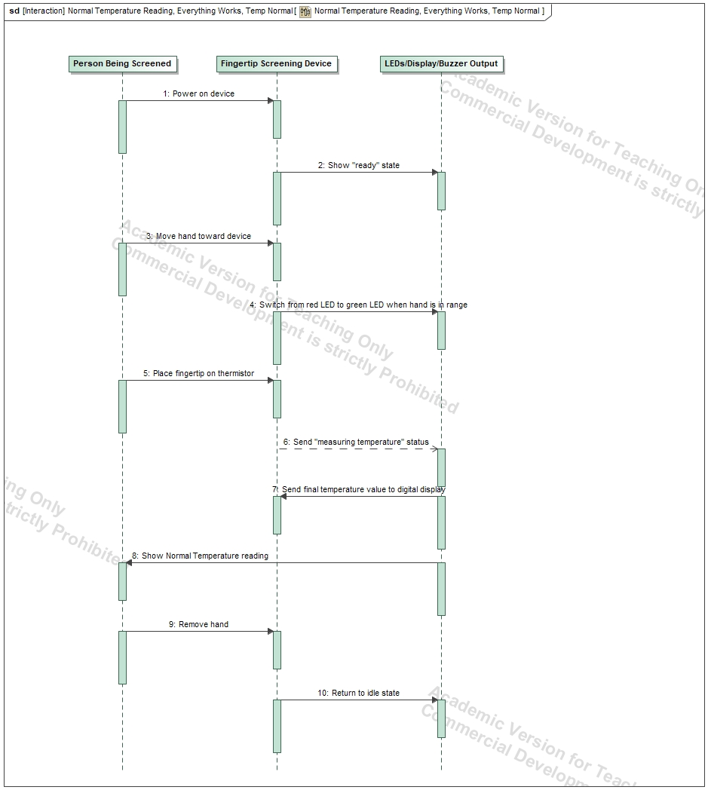

Scenario 2: High Temperature Reading, Possible Fever

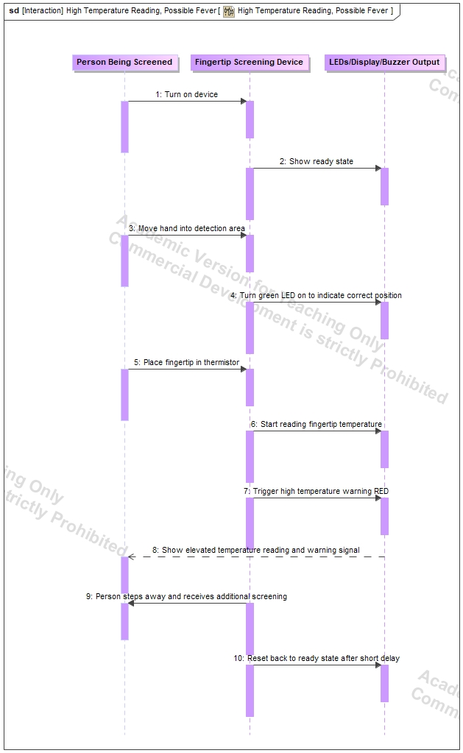

Scenario 3: Hand detected but pulled away too early (Incomplete reading, system resets)

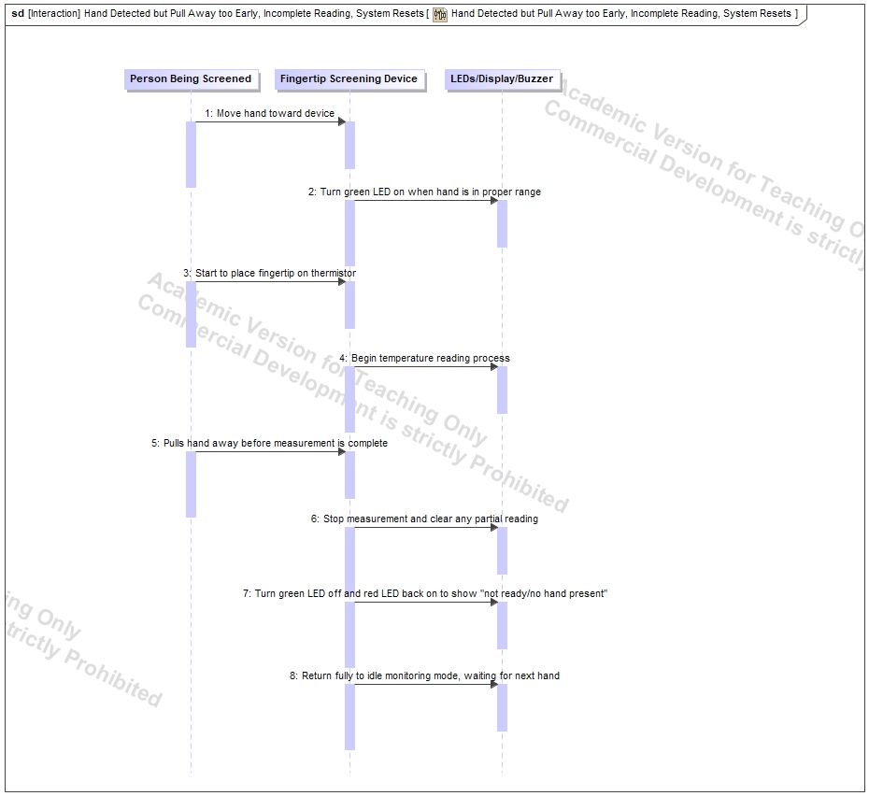

Operational Environment

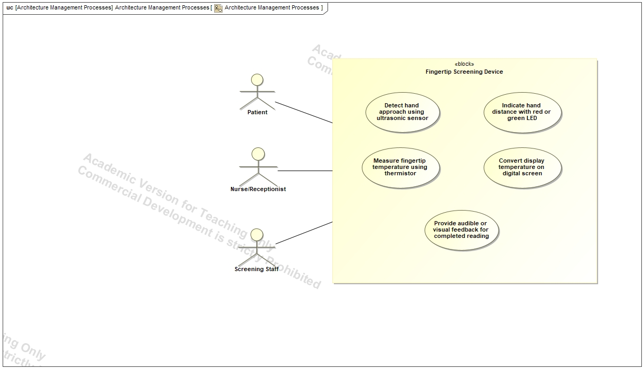

Things We Still Need to Research:

We still need to research several important steps to finish the project and create a polished final prototype. First, we need to learn how to properly mount the digital display onto the board so it stays stable and can be viewed easily ensuring that the temperature is readable during use. We also need to learn how to design and 3D-print a case that can neatly enclose the entire system while leaving openings for only the necessary components, the ultrasonic sensor, the thermistor, the red and green LEDs, and the port that connect the Raspberry Pi board to the computer, so the device looks clean and professional. To do this, we will need to research how to attend the MIX workshop, learn the required software for 3D modeling, and understand how to prepare my design files for printing. Additionally, we need to figure out the best internal layout so all wires, the Raspberry Pi, and the breadboard fit securely inside the casing without clutter. Overall, these steps will help ensure that the final prototype of the device is visually neat, user-friendly, and structurally stable.
- How to mount the digital display securely onto the breadboard or enclosure
- How to design and 3D-print a clean case that hides wires and exposes only the sensors, LEDs, and display
- How to attend MIX training and learn their 3D-printing process/software
- How to model the case correctly with openings for the ultrasonic sensor, thermistor, LEDs, and display
- How to arrange all components so they fit neatly and stay stable inside the enclosure

